Section 1: Functional testing

a) Kamil results:

References:

$JBOSS_HOME - jboss home directory

$GIT - [github repository](https://github.com/kamilsmuga/performance-assignment.git)

Logs for data mining:

$JBOSS_HOME/server/default/log/server.log

$JBOSS_HOME/server/default/log/boot.log

~/.visualvm/1.3.5/var/log/messages.log

/var/log/syslog

# 1. Test suite: Steady state monitoring. Tools integration.

## 1.1. Test case: Clean jboss start. Changed logs rollover at the beginning of each month (for easy log mining) and server.log append=true. Saved jboss server boot logs without any apps deployed - no petstore neither G9.

- edited $JBOSS_HOME/server/default/conf/jboss-log4j.xml :

### <param name="DatePattern" value="'.'yyyy-MM"/>

### <param name="Append" value="true"/>

- started jboss Mon Jun 17 23:46:26 IST 2013

### $JBOSS_HOME/bin/run.sh

- stopped jboss Mon Jun 17 23:48:01 IST 2013

### CTR+C

- log mining results:

## 1.2. Deployed G9.

- deployed G9.ear

### cp -rv G9.ear $JBOSS_HOME/server/default/deploy/

- started jboss Mon Jun 17 23:50:26 IST 2013

- stopped jboss Mon Jun 17 23:51:54 IST 2013

- log mining results:

### 

## 1.3. jboss steady state with VisualVM monitoring

- started jboss Mon Jun 17 23:52:59 IST 2013

- started VisualVM Mon Jun 17 23:54:49 IST 2013

- attached VisualVM Mon Jun 17 23:55:23 IST 2013

- left monitoring to measure stable state results

Heap size start

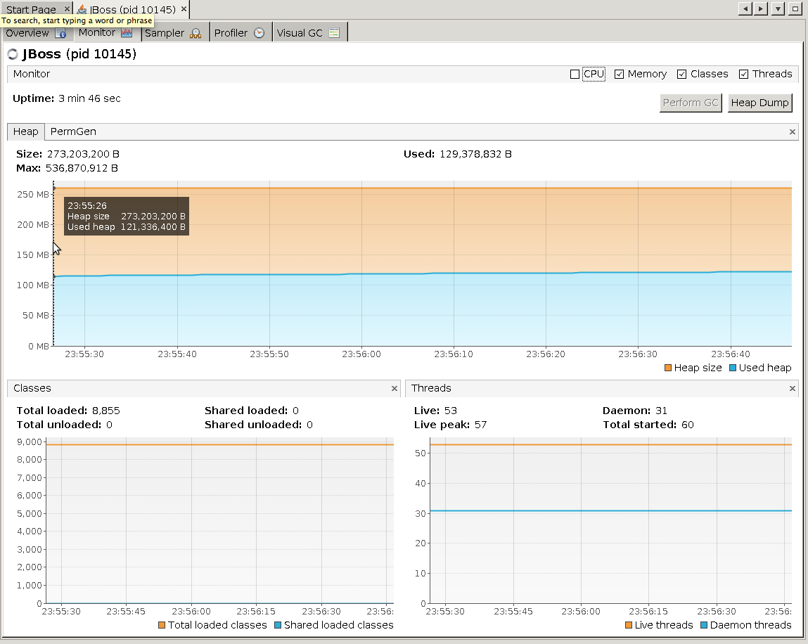

Visual GC start

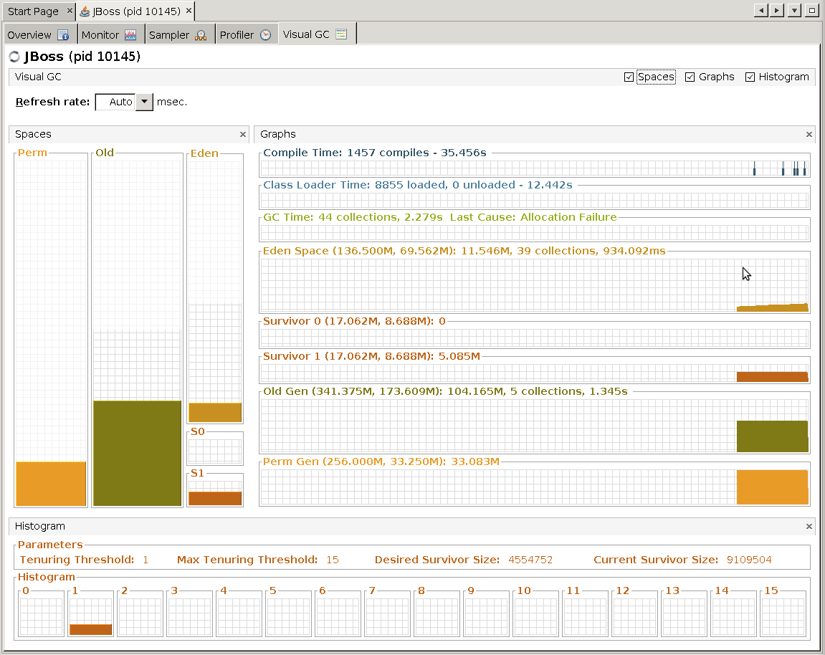

Perm generation start

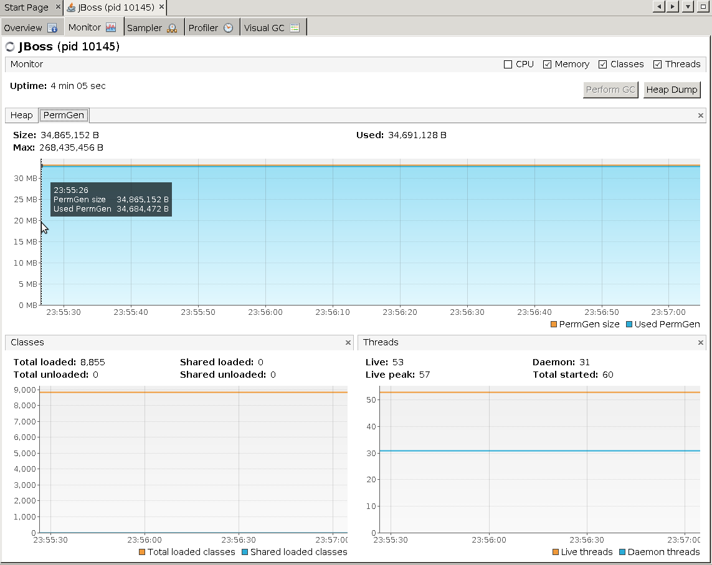

Heap size after 10 mins

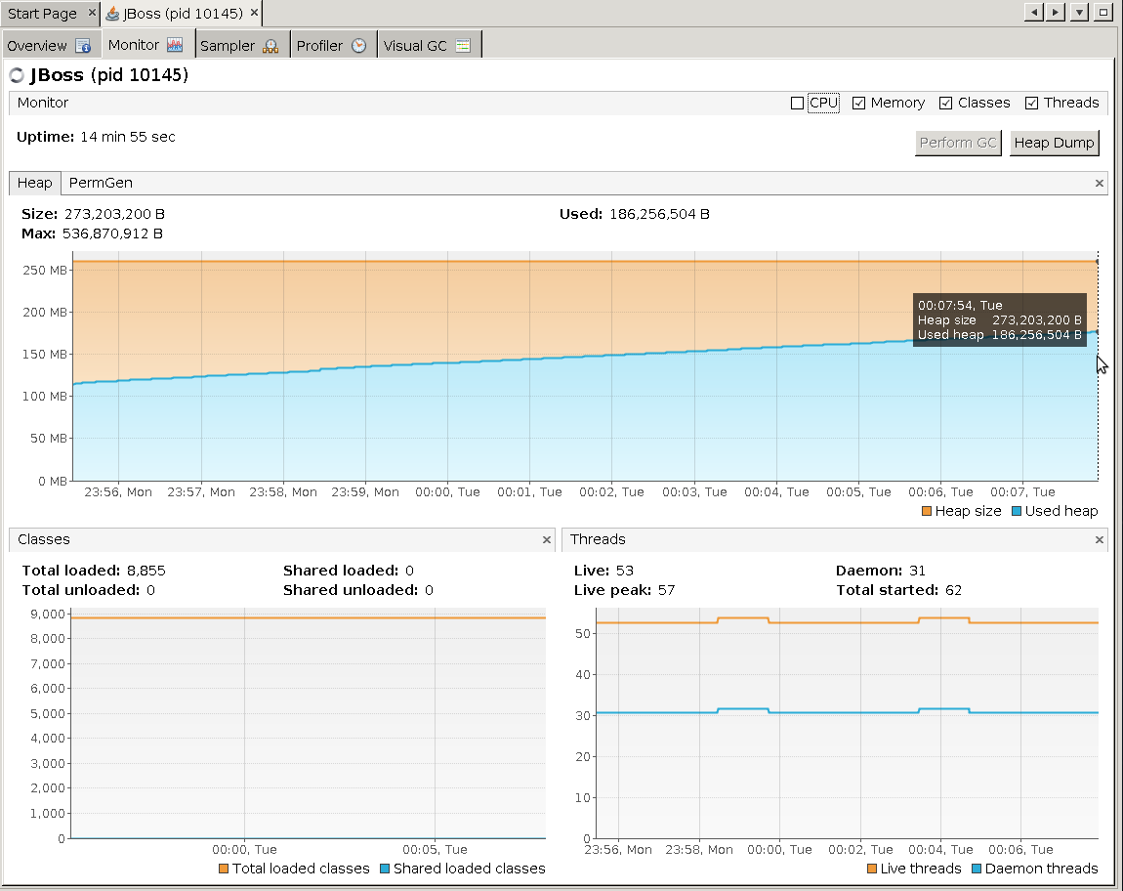

Visual GC after 10 mins

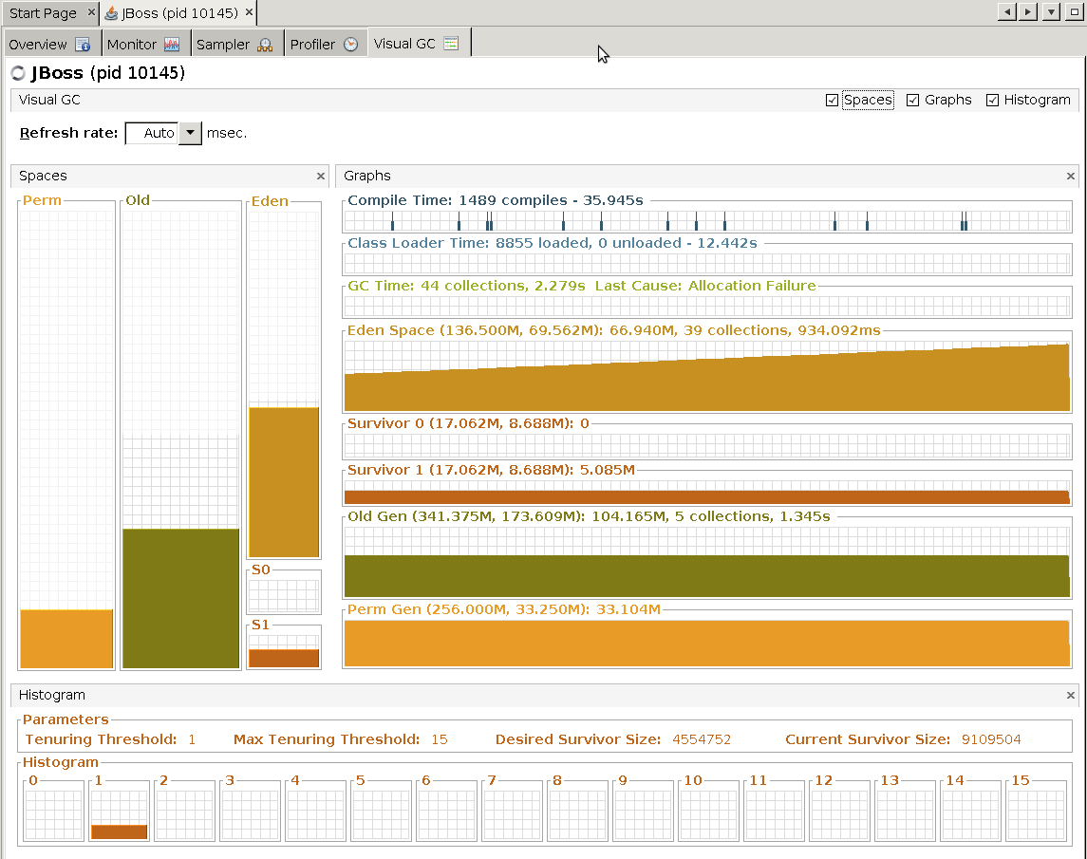

Perm generation after 10 mins

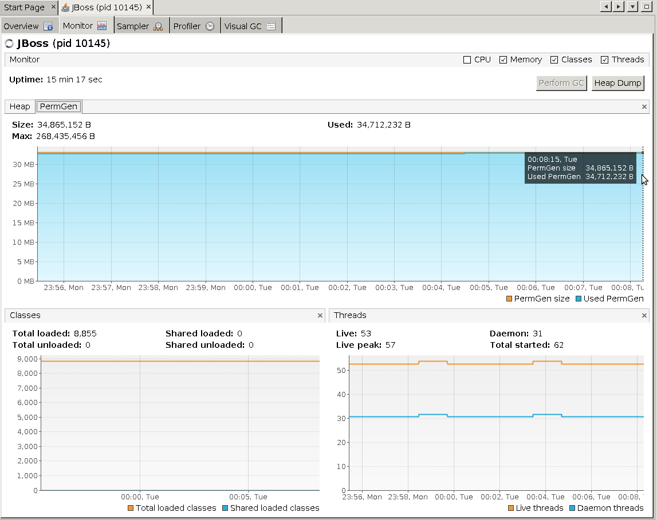

Heap size after full GC

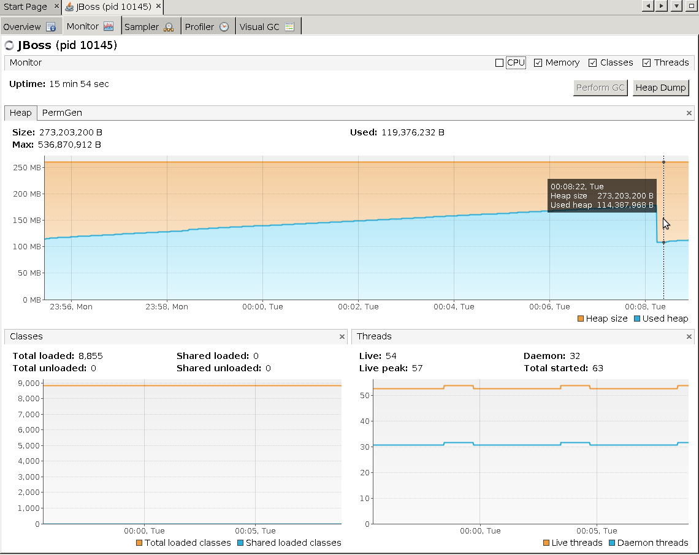

Visual GC after full GC

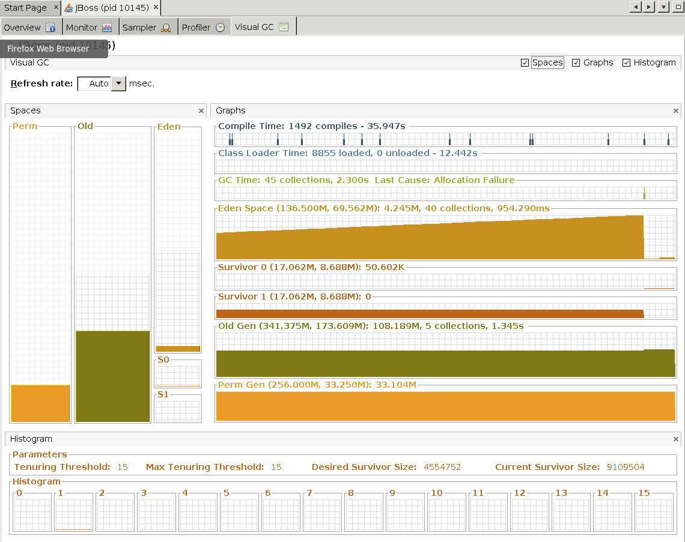

Perm generation after full GC

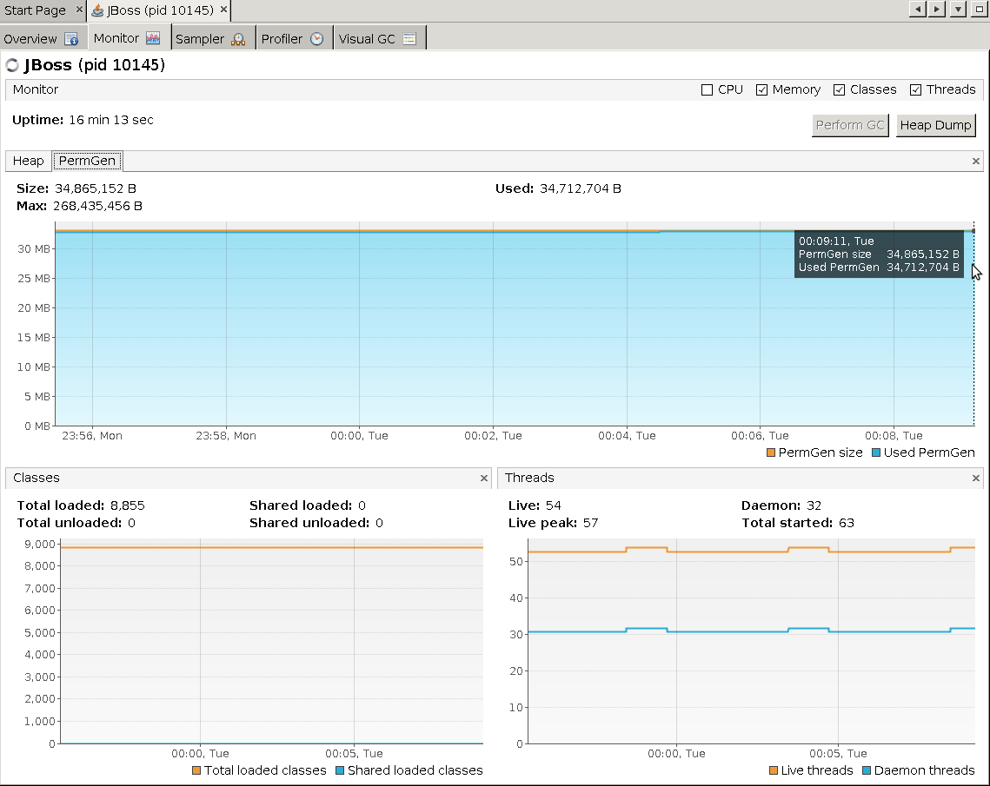

Heap size after 2nd full GC

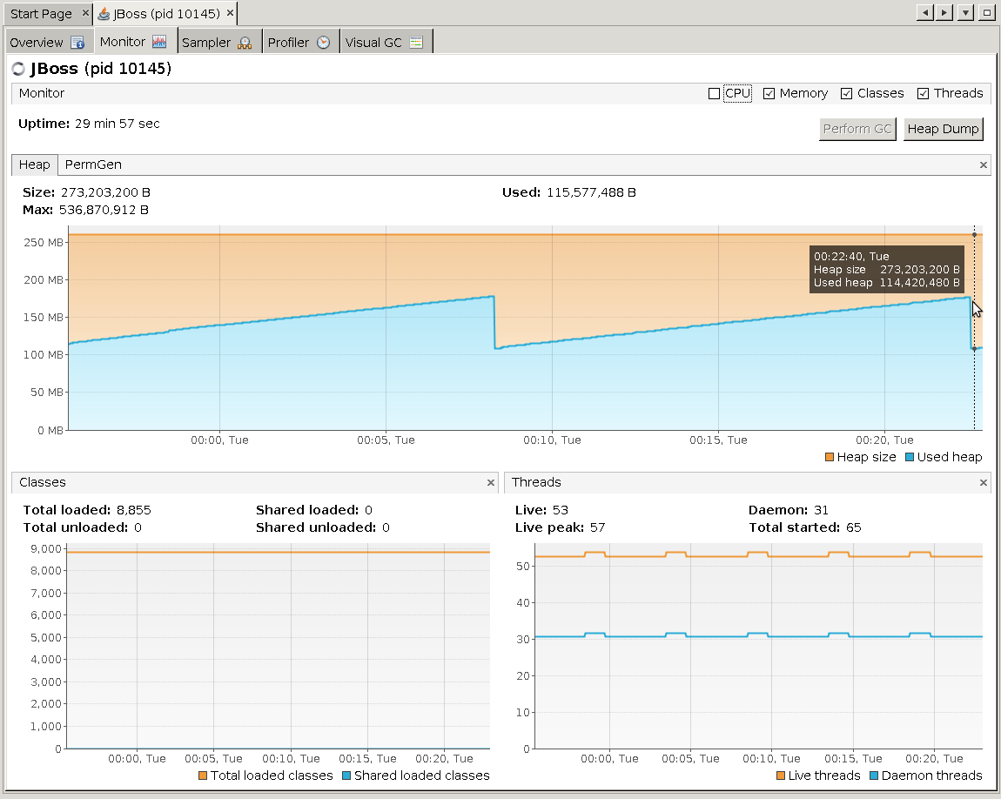

Visual GC after 2nd full GC

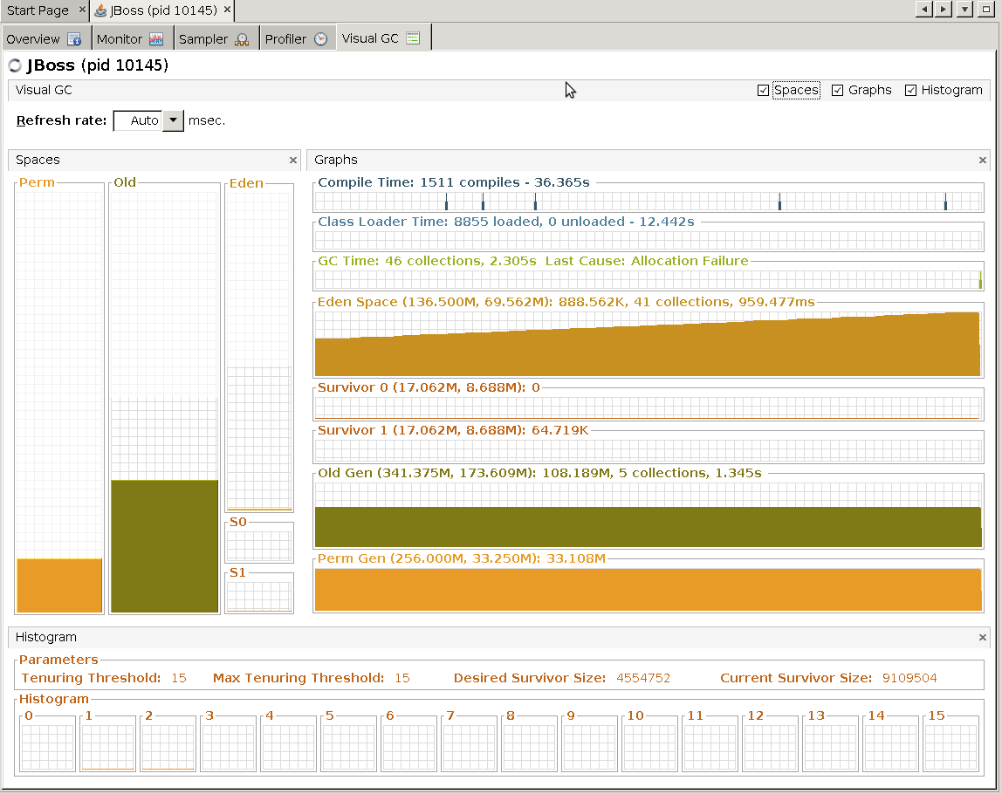

Perm generation after 2nd full GC

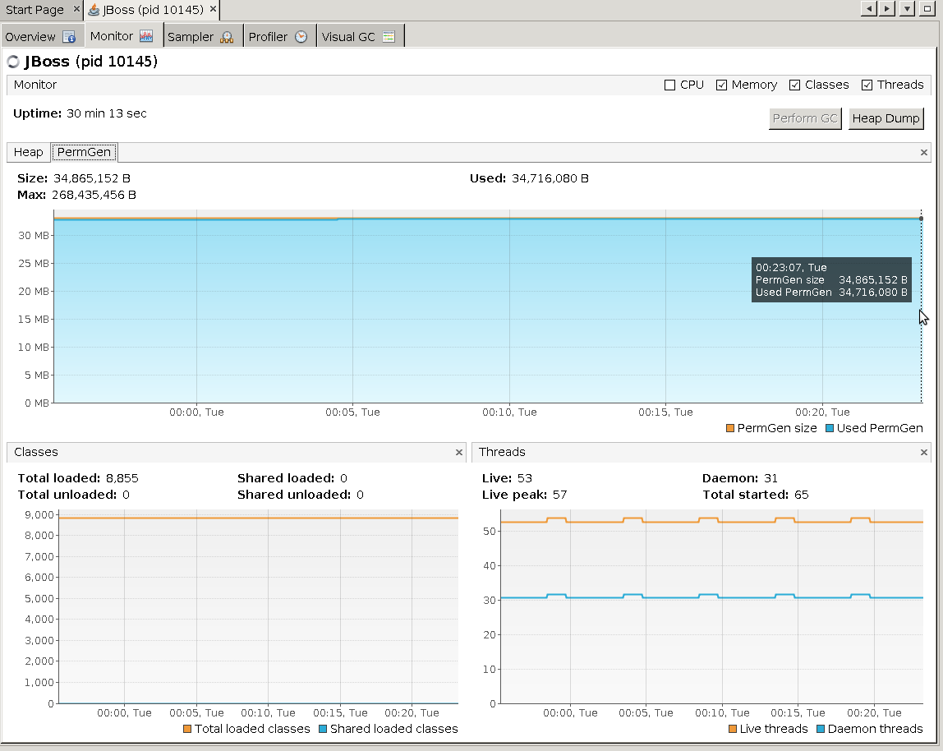

- detached VisualVM Tue Jun 18 00:25:39 IST 2013

- stopped VisualVM Tue Jun 18 00:25:13 IST 2013

- stopped jboss Tue Jun 18 00:25:41 IST 2013

## 1.4. Steady state and CPU profiling

- started jboss Tue Jun 18 00:36:06 IST 2013

- attached VisualVM Tue Jun 18 00:37:09 IST 2013

Heap before CPU profiling enabled

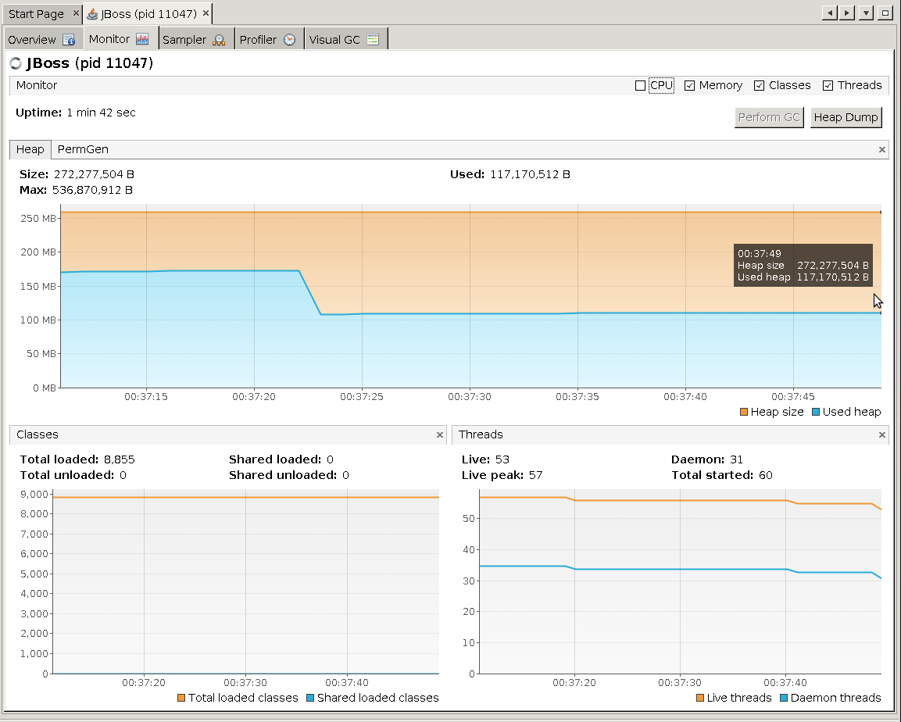

VisualGC before CPU profiling enabled

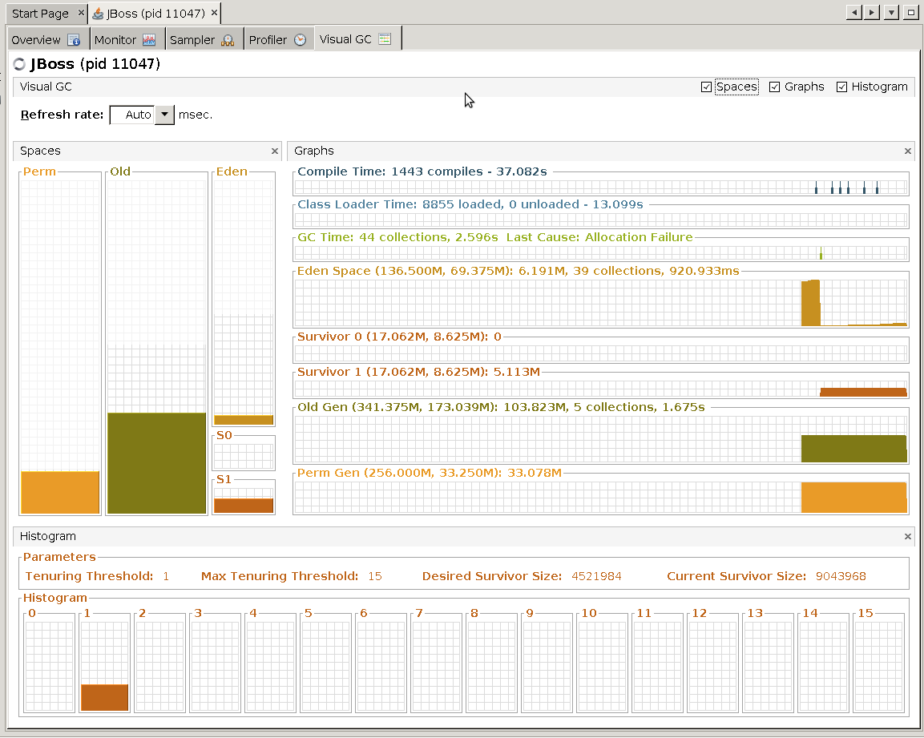

Perm generation before CPU profiling enabled

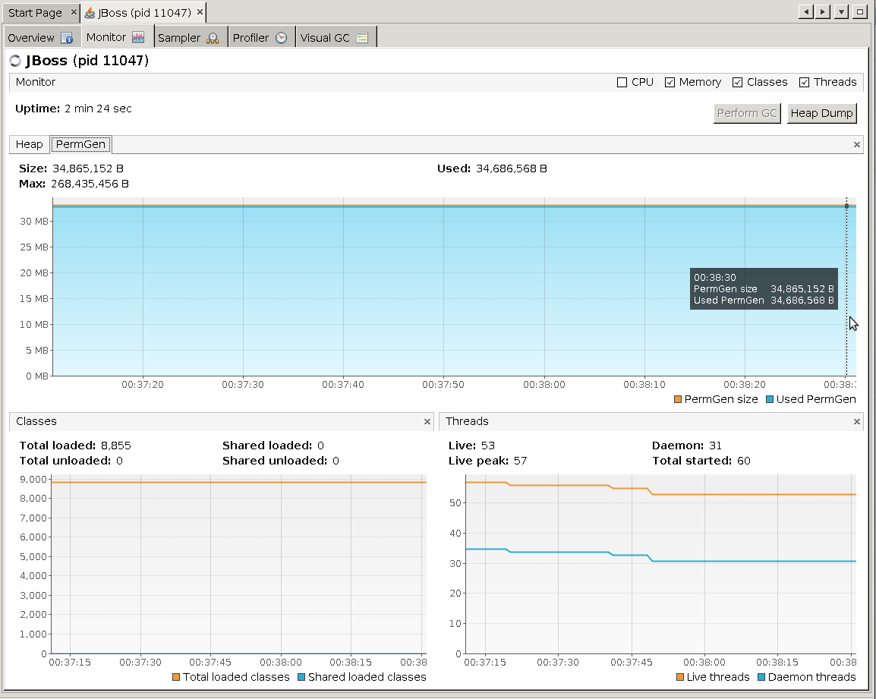

- started CPU profiling with settings Tue Jun 18 00:39:41 IST 2013

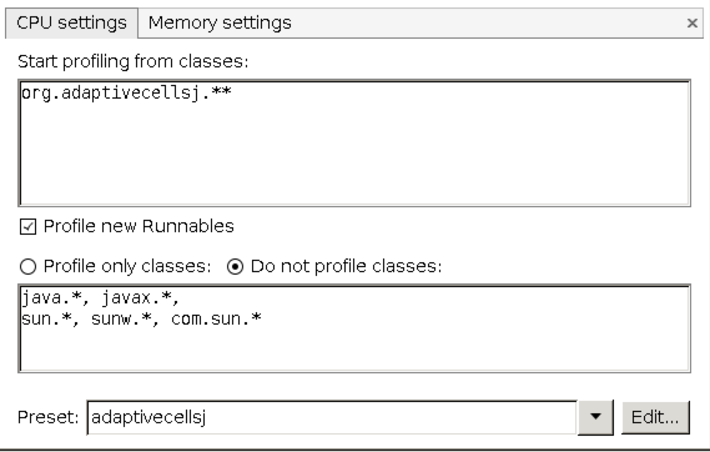

Heap after CPU profiling enabled

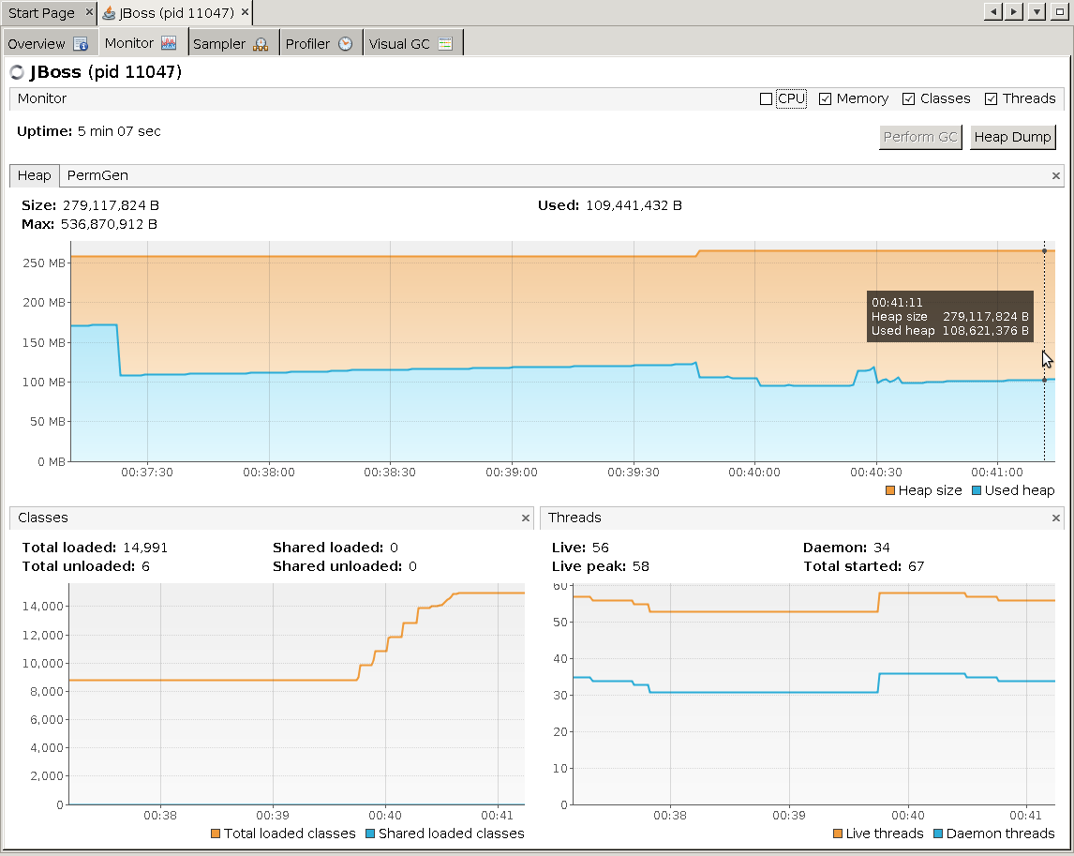

VisualGC after CPU profiling enabled

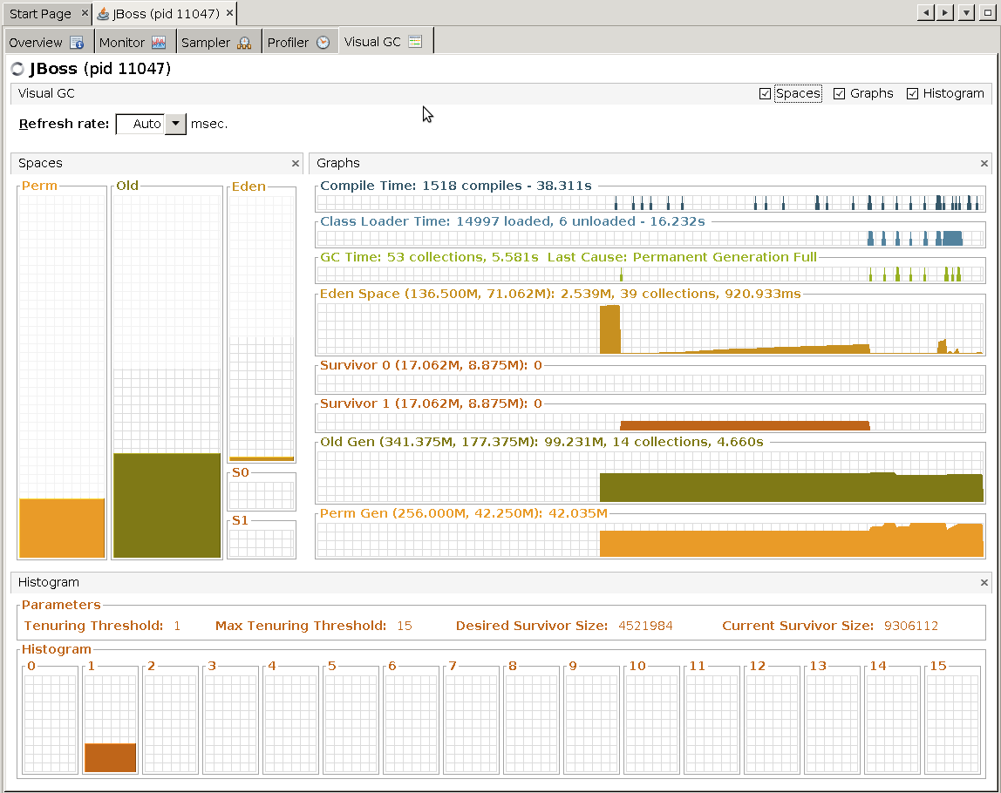

Perm generation after CPU profiling enabled

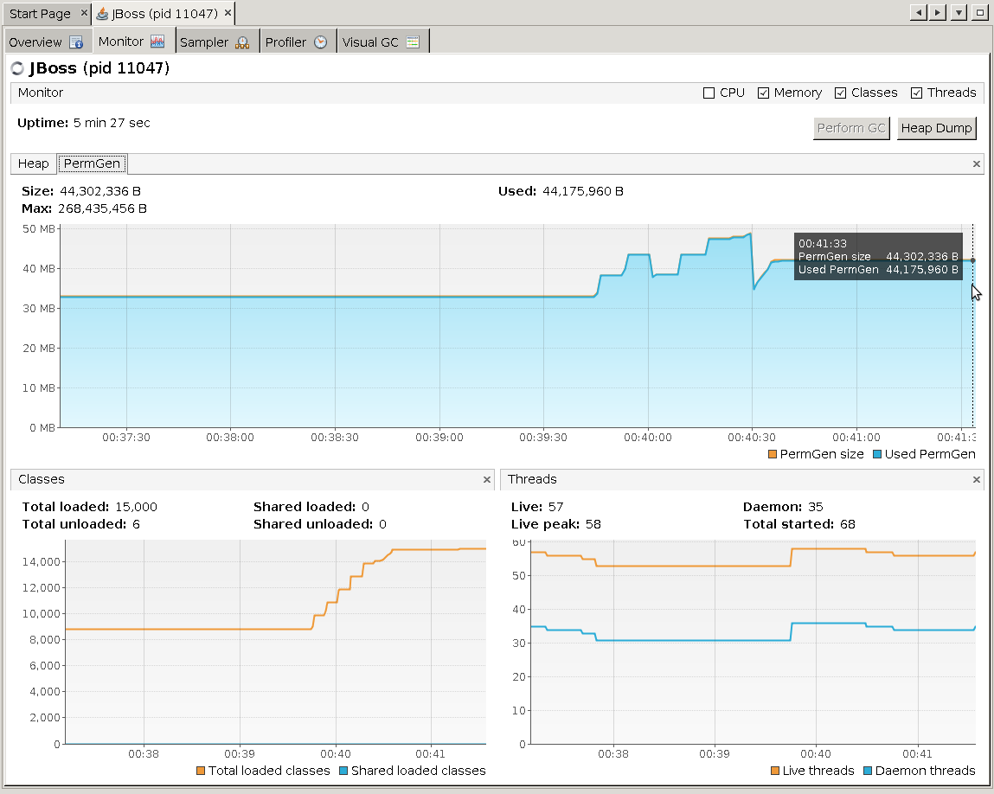

- stopped CPU profiling Tue Jun 18 00:45:31 IST 2013

Top results from CPU profiling:

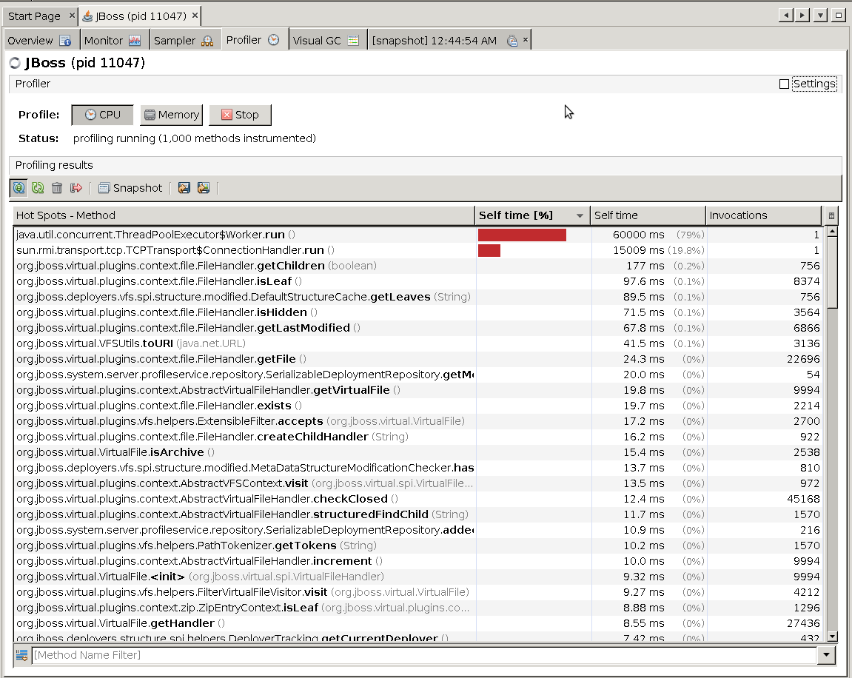

Heap after stopping CPU profiling

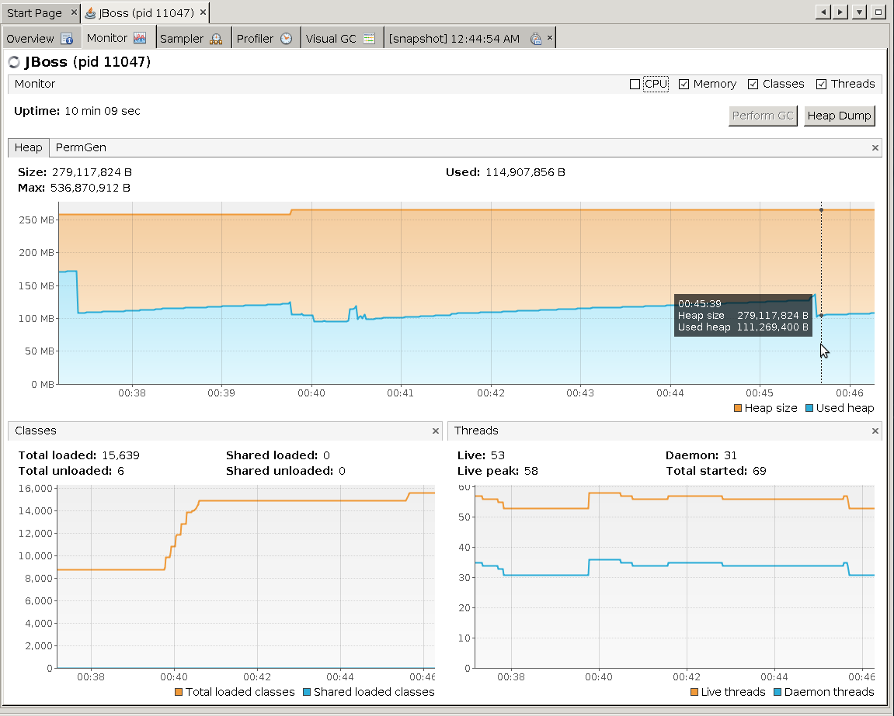

VisualGC after stopping CPU profiling

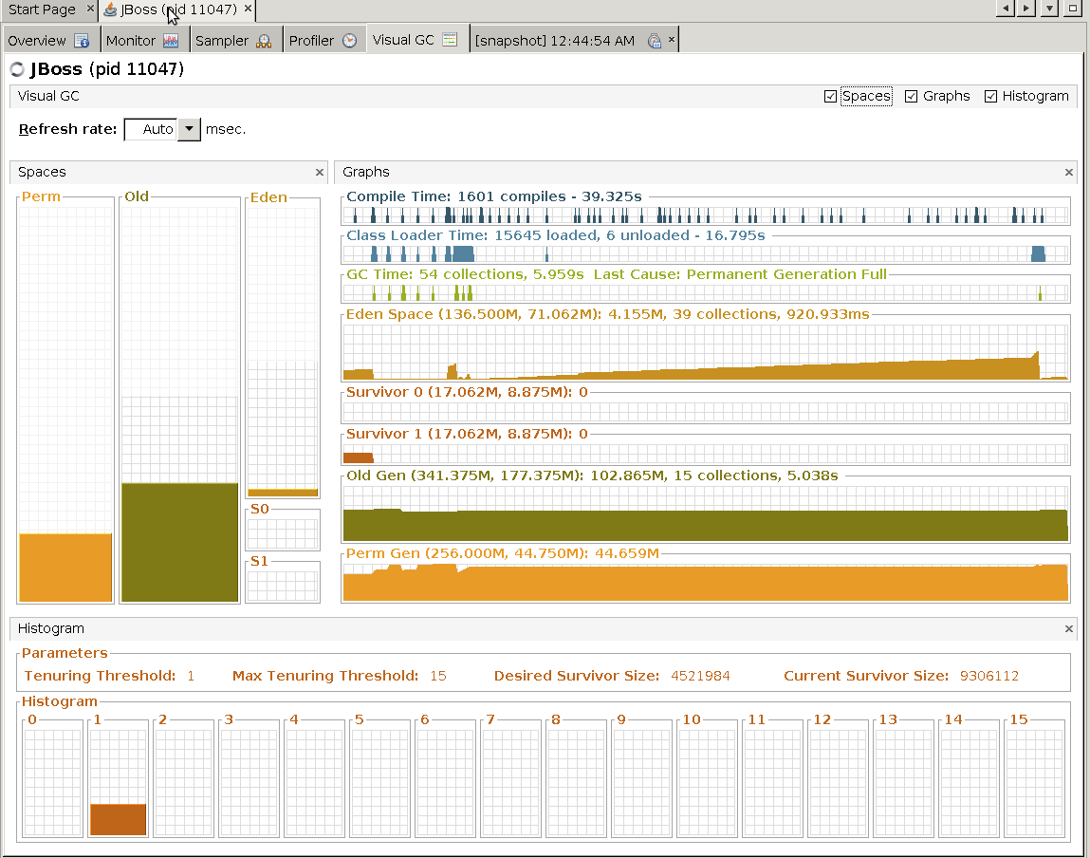

Perm generation after stopping CPU profiling

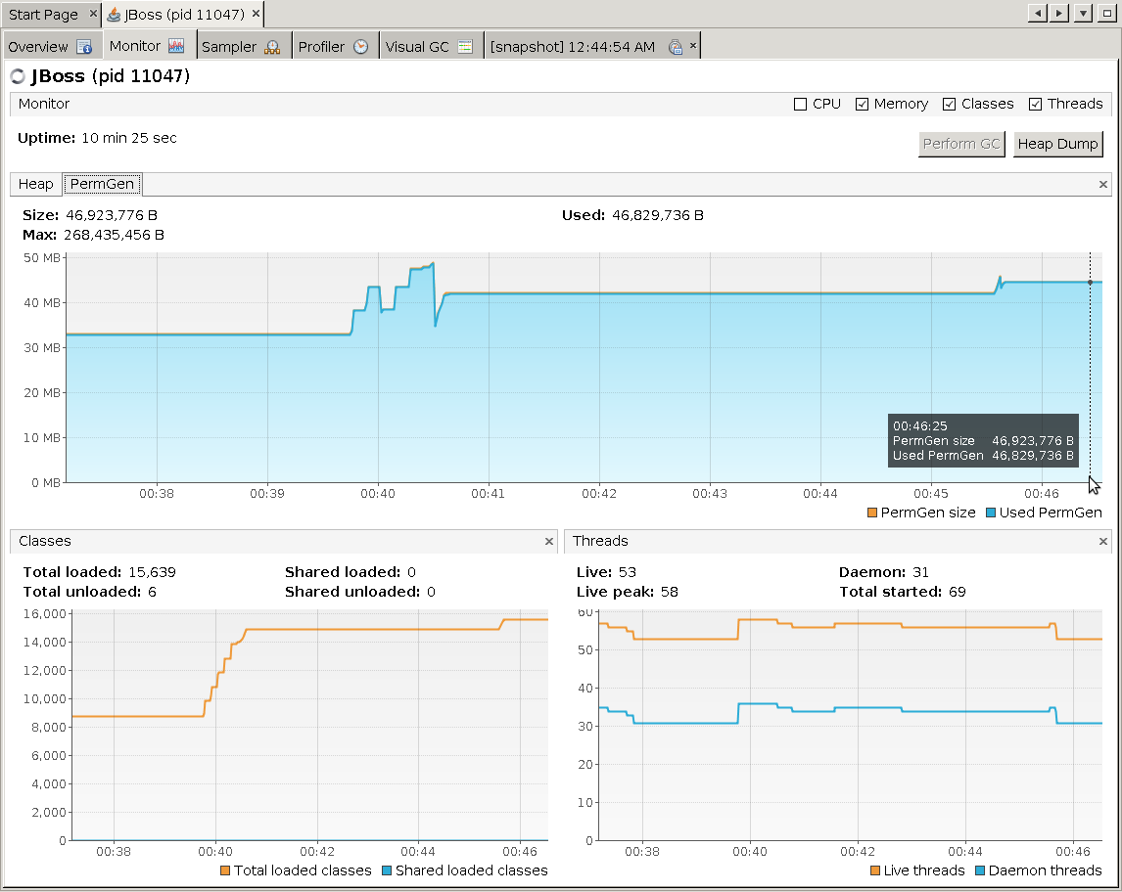

- detached VisualVM Tue Jun 18 00:52:03 IST 2013

- stopped jboss Tue Jun 18 00:52:31 IST 2013

## 1.5. Steady state and memory profiling

- started jboss Thu Jun 20 14:47:15 IST 2013

- attached VisualVM Thu Jun 20 14:52:09 IST 2013

Heap

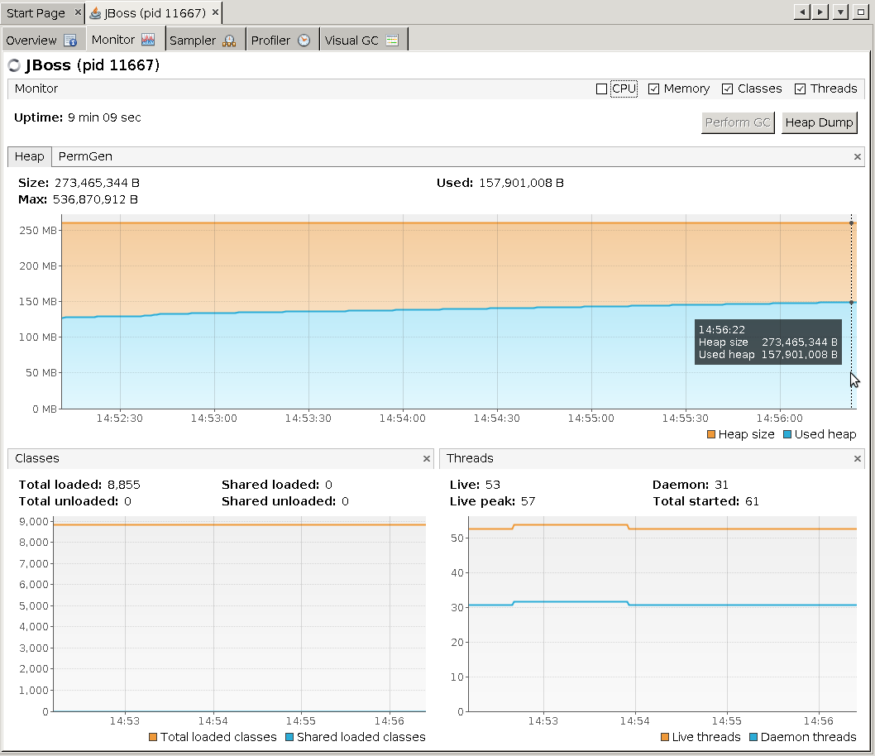

Perm generation

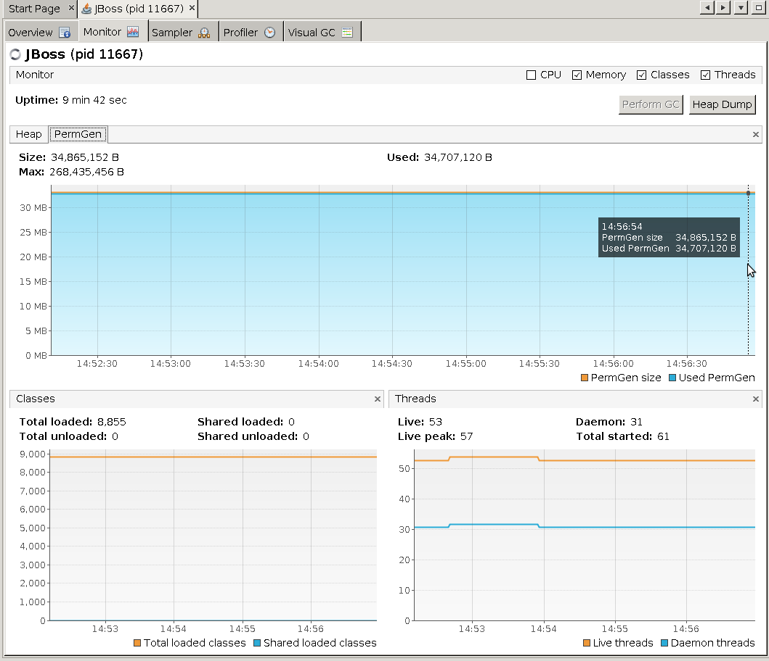

GC

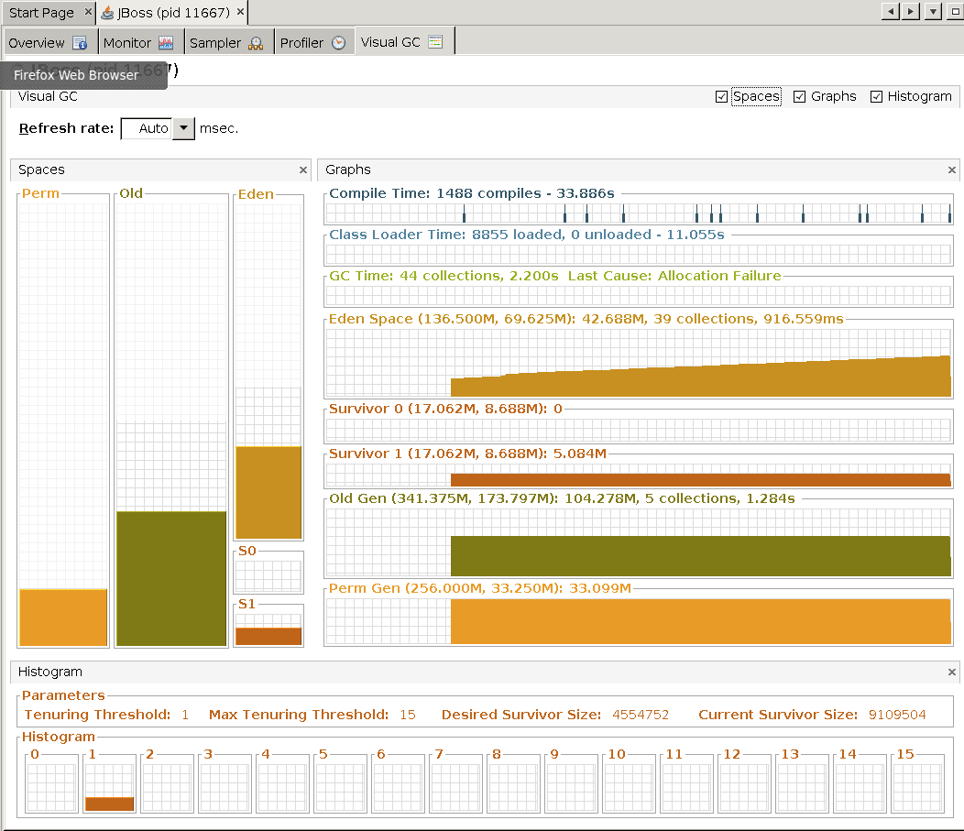

- started Memory profiling Thu Jun 20 14:57:34 IST 2013

Heap

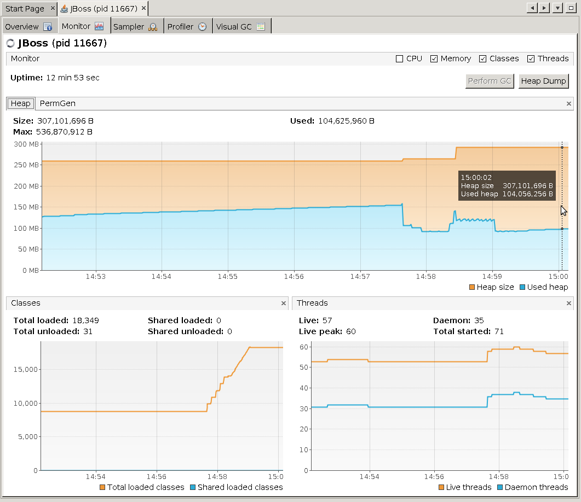

Perm gen

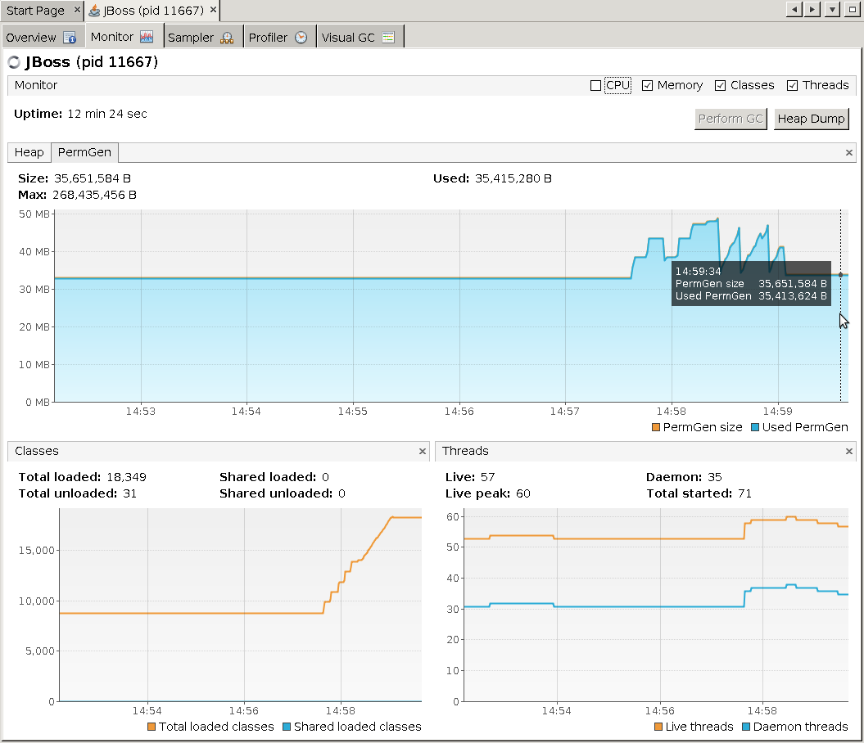

GC

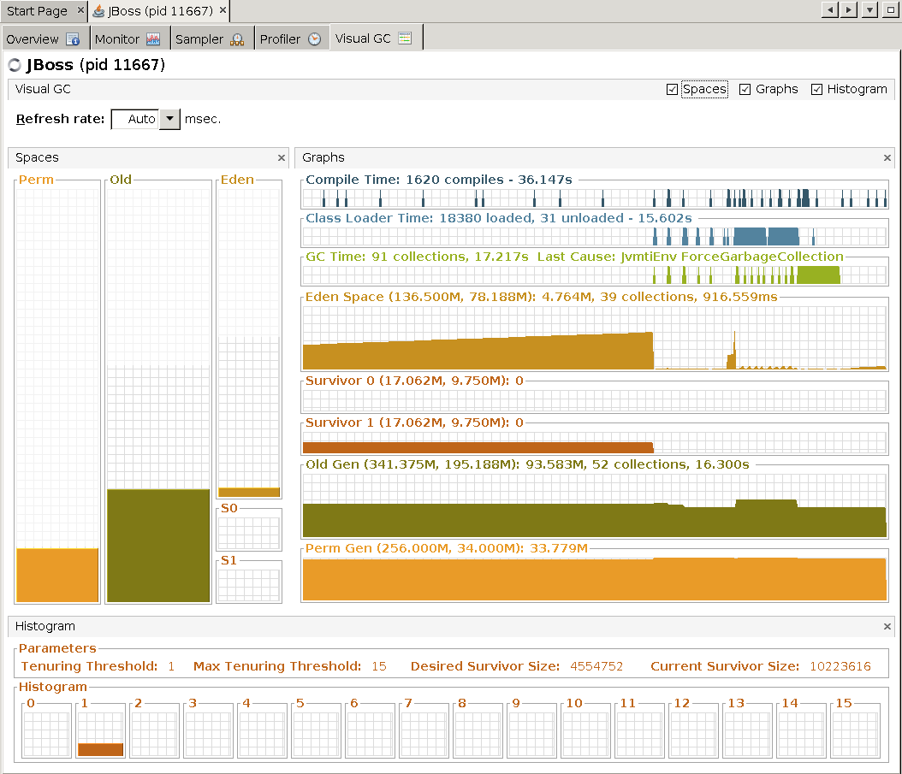

- created snapshot of memory: snapshot-1371737276168.nps at Thu Jun 20 15:07:53 IST 2013

Heap

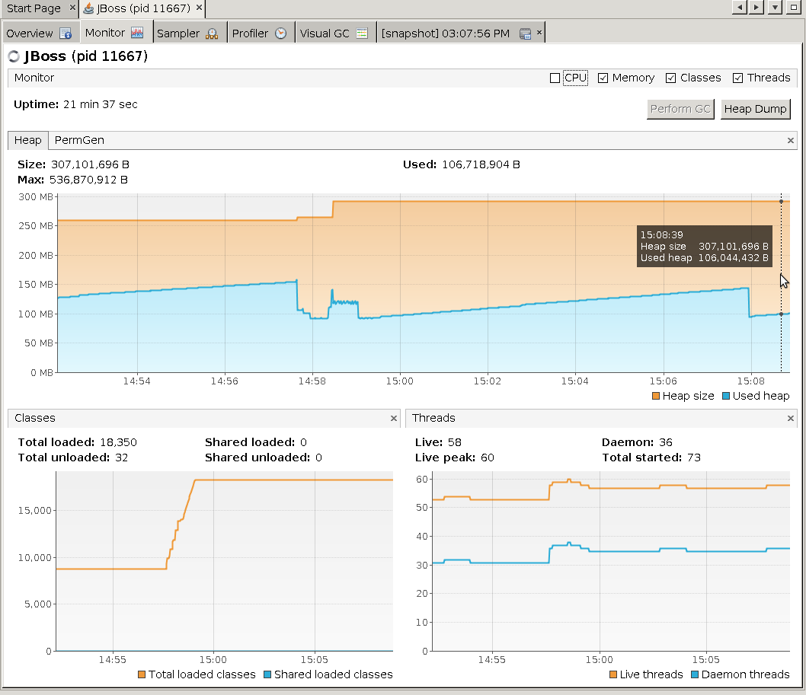

Perm generation

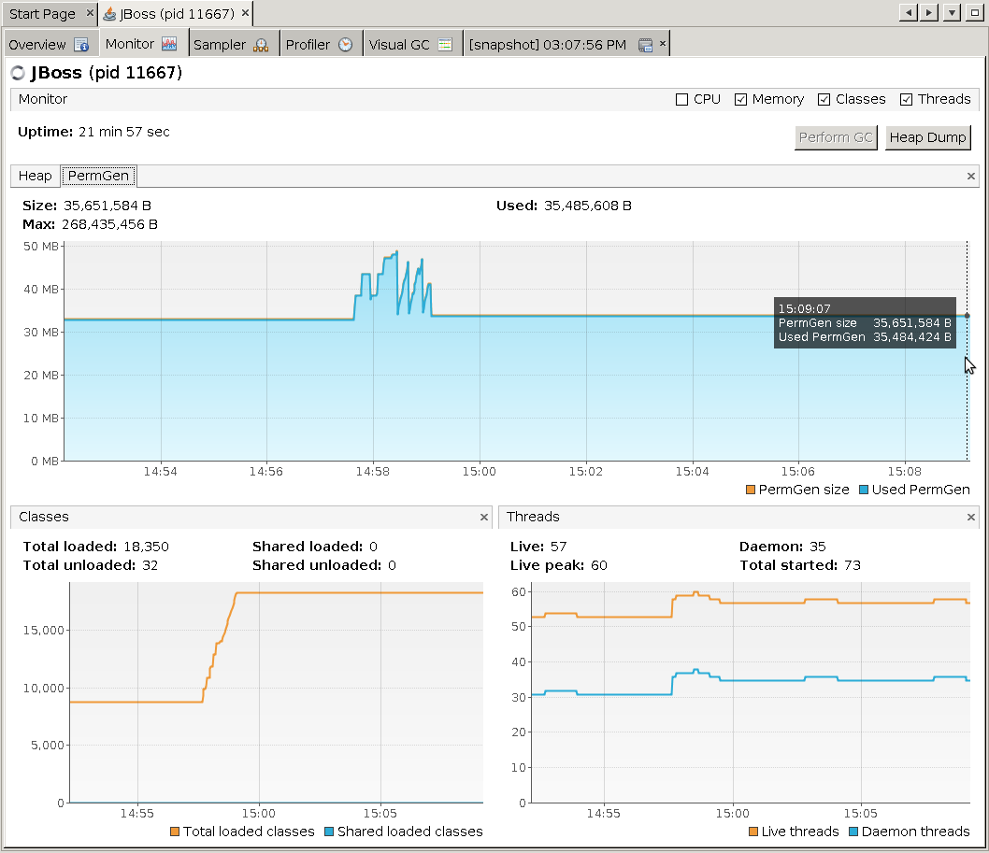

GC

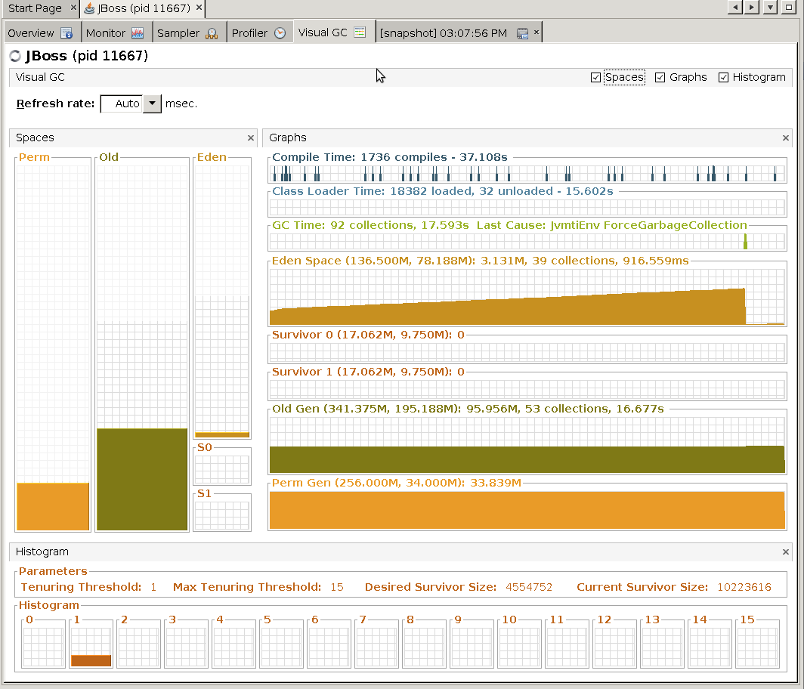

- created another memory snapshot: snapshot-1371737524523.nps at Thu Jun 20 15:11:58 IST 2013

- stopped Memory profiling Thu Jun 20 15:13:28 IST 2013

Heap

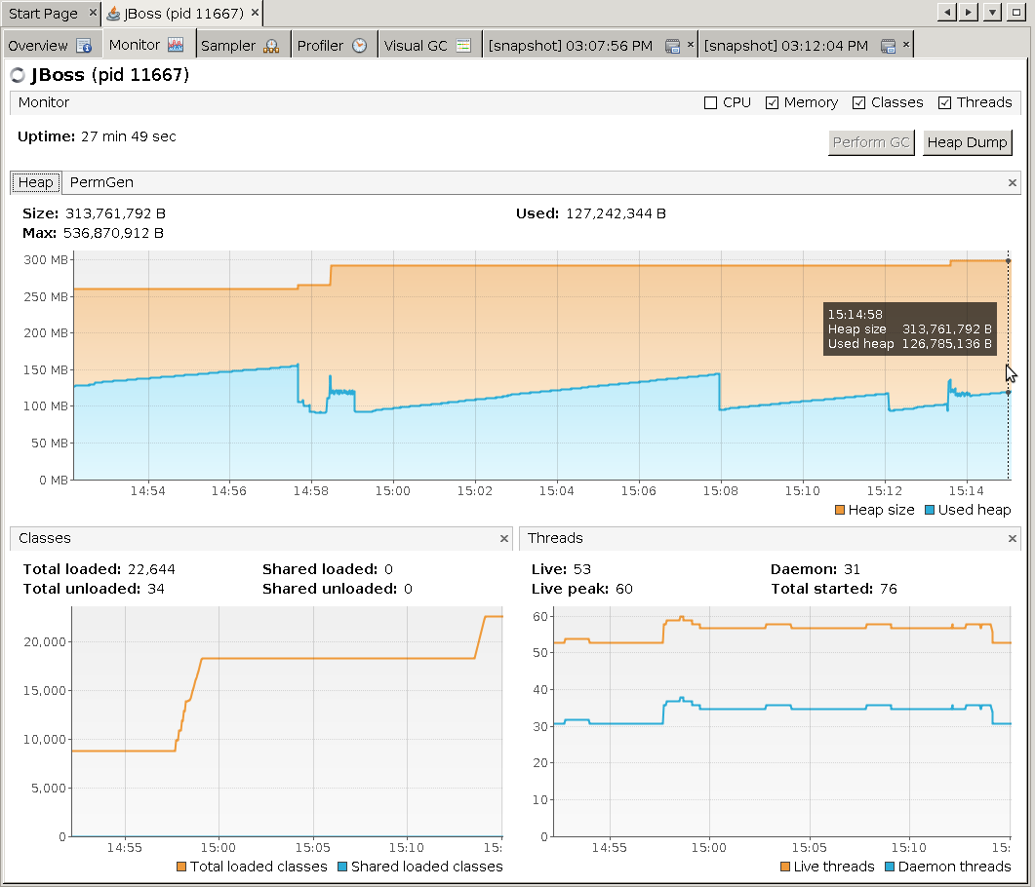

Perm gen

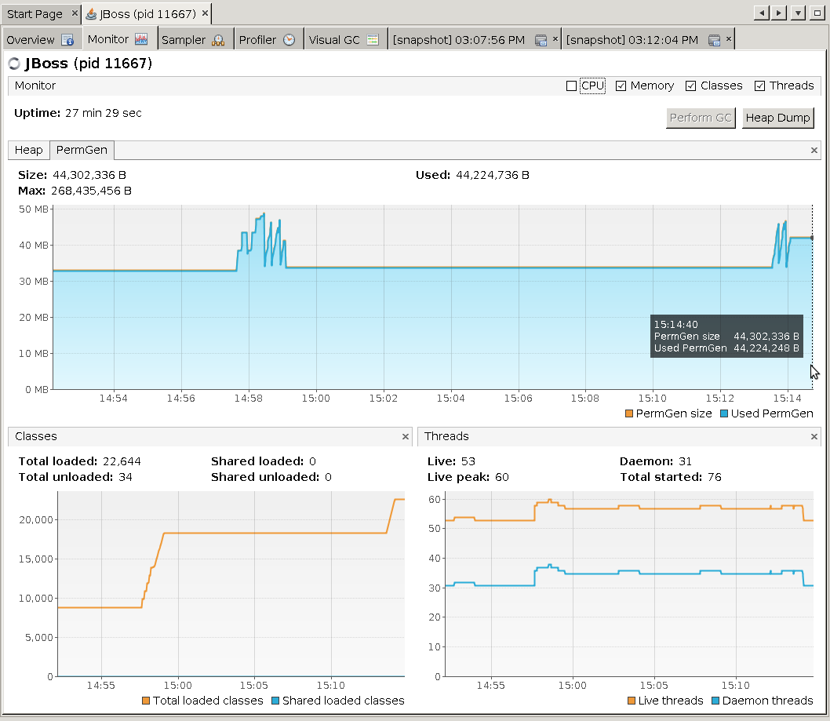

GC

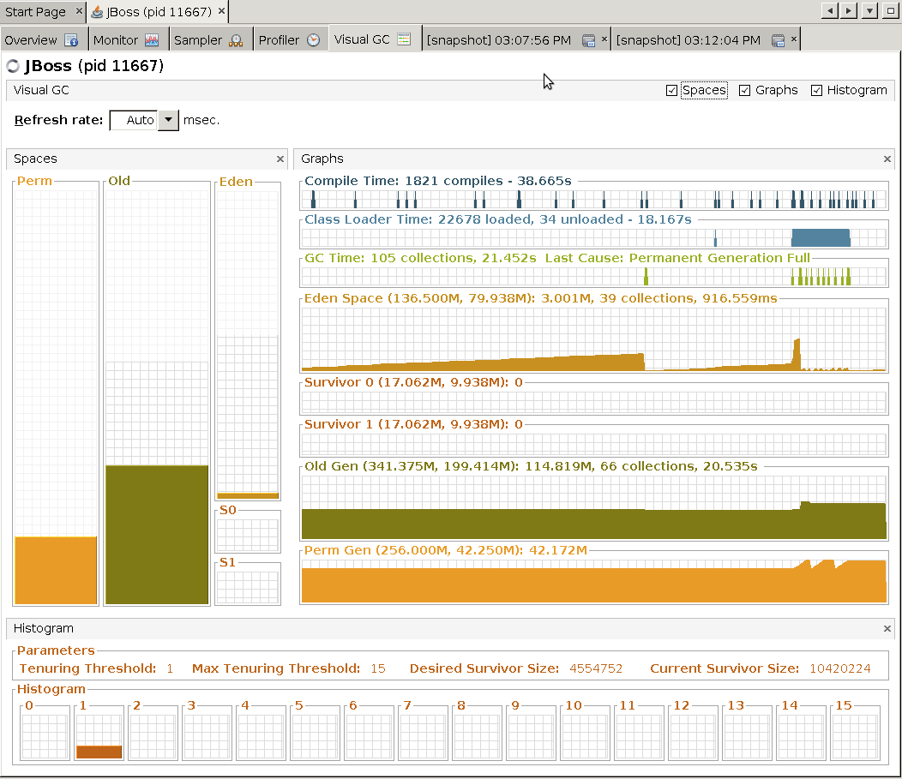

- detached VisualVM Thu Jun 20 15:22:52 IST 2013

- stopped jboss Thu Jun 20 15:23:20 IST 2013

## 

b) Tanveer results: